Help Content UI for EzPGMS

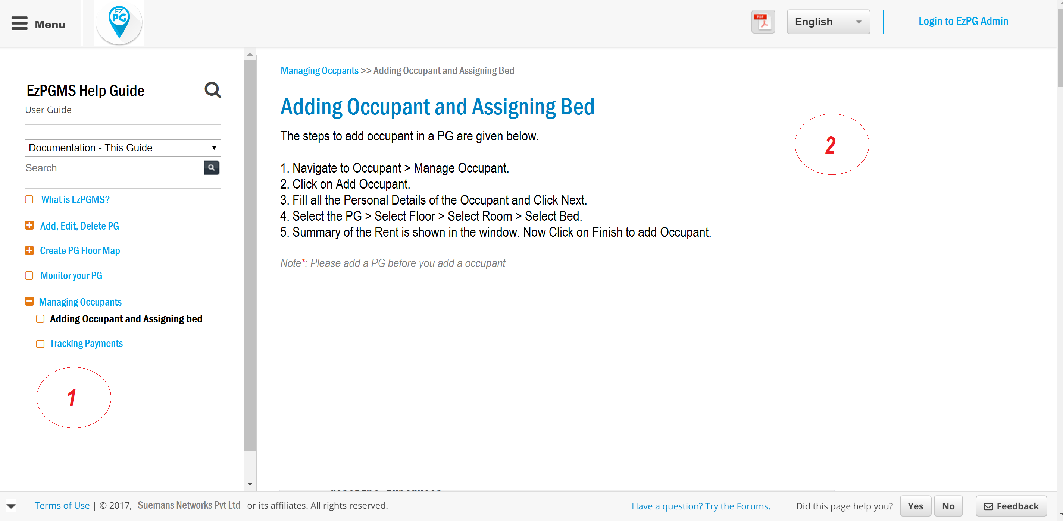

1. The above is the UI for Help Content. The left section that is marked with 1 of the Help Content should be loaded with a json. The json format is attached in the zip named topics.json

2. The right section that is marked with 2 should be loaded from a json file which will be given in the property of the topic as contentFile. Example:

{

“id”:”1”,

“title”:”Managing Occupants”,

“subItems”:[

{

“title”:”Adding Occupants”,

“contentFile”:”addOccupant.json”,

“keywords”:”occupant, occupy bed”

},

{

“title”:”Tracking Payments”,

“contentFile”:”trackPayments.json”,

“keywords”:”track, payments”

}

]

}

3. The search for help content will work based on title and keywords matching.